
1. Complete the sentences with the Present Continuous or Simple. Dopolni povedi s Present Simple (-s/ -es končnica za he, she, it) ali Present Continuous (am/ is/ are + -ing). Pomagaj si s časovnimi prislovi (now, today, usually itd.).

- I _________ (not/listen) to the radio very often.
- How often ____________ (you/read) sport magazines?
- Turn off the TV! You ______________ (not/watch) it.
- It`s very late. I __________ (go) home now. ____________ (you/came) with me?
- She ____________ (phone) her grandmother. She ___________(phone) her every day.
- My mother usually __________ (drive) to work, but today she ________(go) by bus.
- That photographer ___________ (take) very good photos. Look! He _______
_______(take) a photo now.
- It always _____________ (rain) at the weekend, but today the sun __________(shine).
PRESENT CONTINUOUS

- Nekaj, kar se dogaja zdaj. (smo sredi nekega dogajanja.)
Now she is reading.

- Začasno dejanje.
They are living in the camp for two weeks.

Now, at the moment, today, at present
PRESENT SIMPLE

- Dnevna rutina
We get up early every morning.

- Ponavljajoče dejanje
I often call my parents.

- Trajno dejstvo ali stanje
The Statue of Liberty is in New York.

Always, usually, often, normally

2. Write DO or DOES. Vstavi DO ali DOES.

- ____________________ you play football on Fridays?
- ____________________ Mark watch TV all day?
- ____________________ my sister read books?
- ____________________ my friends like music?
- ____________________ you read newspapers?

3. Write DON’T or DOESN’T. Vstavi DON’T ali DOESN’T.

- She ____________________ get up at seven o'clock.
- We ____________________ speak Chinese.
- I ____________________ like fish.
- My mother ____________________ listen to the radio.
- They ____________________ like beer.

4. Circle the correct answer. Obkroži pravilni odgovor.

- We don’t speak / isn’t speaking / no speak Spanish.
- George is watching / watch / watches TV now.
- They have / having / are having breakfast every morning at 8 o'clock.
- Mary is cleaning / clean / cleans her teeth at the moment.
- John drink / drinks / is drinking coffee every day after lunch

5. Write am/ is/ are and answer the question. Zapiši am/ is/ are in odgovori na vprašanje. Poglej primer.

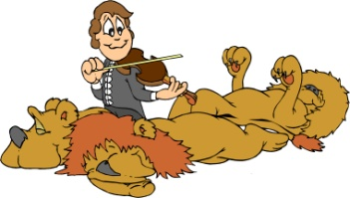ARE the lions sleeping? __YES, THEY ARE.
 ……………… the man playing? …………………………
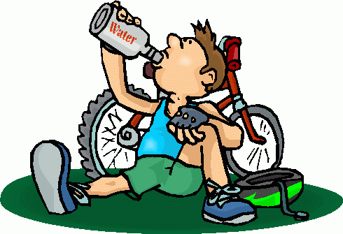 ………………… I drinking water?.................................
 …………………. it snowing?................................................
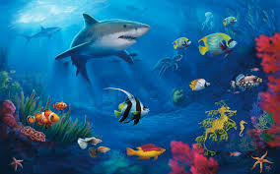 ……………….. the fish swimming? ……………………
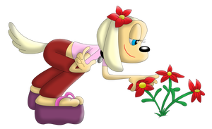…………….. she picking flowers?...............................
…………… we going to school?..................................

6. Complete the sentences. Use Present Continuous and answer the question. Dopolni povedi, uporabi Present Continuous in odgovori na vprašanje.

…IS…. the rhino …SLEEPING…(sleep)?....YES, HE IS.............
 ………….. she ……………………(wear) a dress?.............................
 ………….. they ………………….(drive)? ………………
…………. they ……………………..(dance)?.....................
 …….. the sun ………………….(shine)?.....................
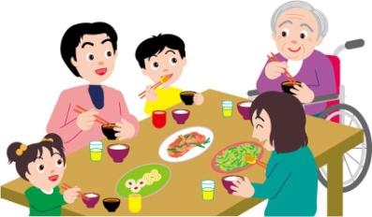………… they ……………….(play)?..........................
………… it …………………….(listen) to music?
……………… the children ……………….(cook)? …………………………………..
 ………….. they ………………..(talk)?............................
 …………. they ………………….(watch) TV?..................

COUNTRIES AND NATIONALITIES

COUNTRY  (država) | NATIONALITY  (narodnost) | LANGUAGE  (jezik)
Portugal | Portuguese | Portuguese
Spain | Spanish | Spanish
England | English | English
France | French | French
Germany | German | German
Italy | Italian | Italian
Russia | Russian | Russian
Austria | Austrian | Austrian
Greece | Greek | Greek
The USA | American | American
Japan | Japanese | Japanese
Croatia | Croatian | Croatian
Brazil | Brazilian | Brazilian
China | Chinese | Chinese

7. Complete the table. Dopolni razpredelnico.

COUNTRY / država | NATIONALITY / narodnost | LANGUAGE / jezik
France | French
Spain |  | Spanish
Slovenia
Italy |  | Italian
Austria | Austrian
Greece | Greek
Croatia
Hungary | Hungarian
England | English
Russia |  | Russian

Hello there! We are from Germany. So we are German!
Pozdravljeni, prihajamo iz Nemčije. Torej smo Nemci.

What about you? Kaj pa ti?
Where are you from? Iz kje si ti?
I am from _____________________________.
What nationality are you? Katere narodnosti si?
I am _______________________________.

8. Follow the example and complete the sentences with the correct nationality. Poglej primer in reši spodnjo nalogo, pomagaj si s tabelo na prejšnji strain.

- I am from Spain. I am SPANISH.
- You are from France. You …………………………………………………
- He is from the USA. He ……………………………………………………….
- She is from China. She ……………………………………………………….
- It is from Italy. It ……………………………………………………………...
- We are from Brazil. We ………………………………………………………
- You are from Germany. You ………………………………………………
- They are from Greece. They ……………………………………………
- Leo is from Austria. ………………………………………………………..
10. Ann and Chun are from Japan. ………………………………………..

9. Now do the other way round and find out which country is missing! Poglej primer in reši spodnjo nalogo, pomagaj si s tabelo na prejšnji strain.

- I am Austrian. I am from AUSTRIA.
- You are American. You ……………………………………………….......
- He is Italian. He ……………………………………………………….........
- She is Chinese. She …………………………………………………………….
- It is French. It …………………………………………………………………….
- We are Japanese. We ………………………………………………………..
- You are English. You ………………………………………………………….
- They are Spanish. They ………………………………………………………
- Johanna is Greek. ………………………………………………………......
10. Lewis and Gwen are German. …………………………………………..

Good job

