1. Circle the correct form of the verb to be. Obkroži pravilno obliko glagola biti – am/ is/ are.

Hello, my name AM/ IS/ ARE James.
I AM/ IS/ ARE 13 years old.
I AM/ IS/ ARE a student.
Mitch AM/ IS/ ARE my older brother.
He AM/ IS/ ARE 15 years old and Matt AM/ IS/ ARE my younger brother.
He AM/ IS/ ARE 10.
My best friends AM/ IS/ ARE Tom and Peter. They AM/ IS/ ARE students too. 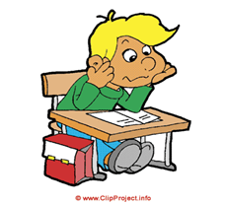

PRESENT SIMPLE je sedanji čas, ki opisuje navade, ponavljanja, stanja in dejstva.
OBLIKA: GLAGOL + končnica –s/-es (za tretjo osebo ednine: he/she/it)

Pogosta prislovna določila, ki nam pomagajo prepoznati, kdaj uporabimo čas Present Simple Tense so:
normally (običajno), every (vsak), always (vedno), often (pogosto), sometimes (včasih), usually (ponavadi), occasionally (priložnostno), rarely (redko kdaj), seldom (redko kdaj), hardly ever (skoraj nikoli), never (nikoli).

2. Choose the right option for PRESENT SIMPLE. Izberi pravo možnost za Present Simple. Pazi na končnice –s/ -es pri he/ she/ it

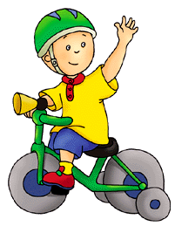
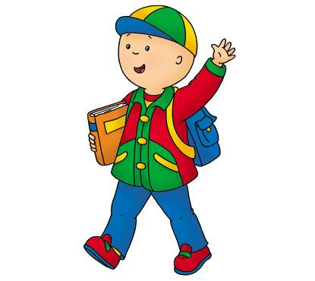
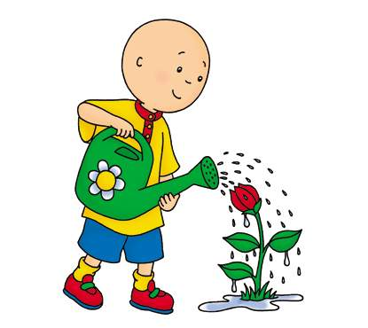
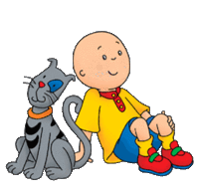
PRIMER:
1. He __C_ _ a tricycle.
a. ride
b. riding
c. rides
2. He __________ to school.
a. walks
b. walk
c. walking

3. He_________ with his pet.
a. playing
b. play
c. plays

4. He __________the flower.
a. watering
b. waters
c. water

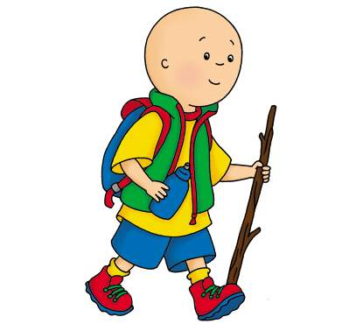
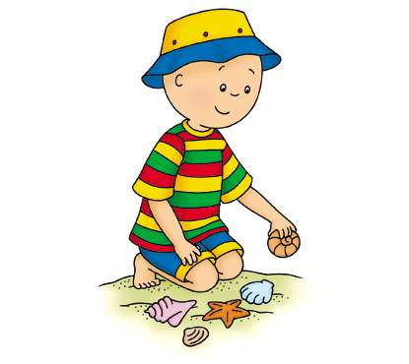
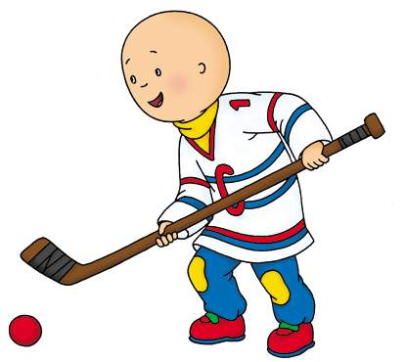

5. He _______ hiking.
a. loves
b. loving
c. love

6. He _____________
seashells.
a. collects
b. collect
c. collecting

7.He ______ a hockey
player.
a. am
b. is
c. are

8. He _______ in the park.
a. runs
b. running
c. run



13. He ____________ confused.
a. feels
b. feeling
c. feel

16. He ___________
skiing.
a. hates
b. hate
c. hating


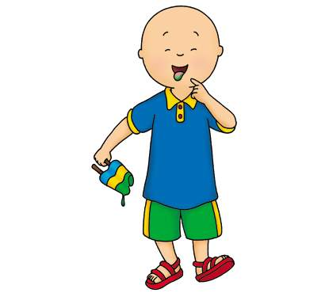
11. He __________ the bird house.
a. paints
b. painting
c. paint

12. He _________ an
ice cream.
a. eat
b. eats
c. eating

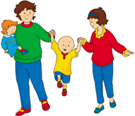
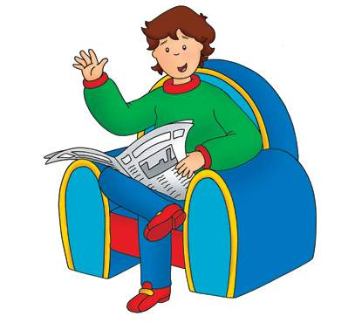
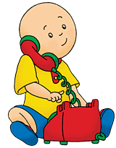

17. They _______ to the park on Sundays.
a. going
b. goes
c. go

18. His mother _____
the newspaper.
a. reads
b. read
c. reading
19. He __________ his grandparents at six.
a. call
b. calls
c. calling

20. He ____________
goodbye.
a. waves
b. waving
c. wave

KAJ DELAJO LJUDJE NA SLIČICAH?
PRESENT CONTINUOUS je opisni sedanji čas.
OBLIKA: GLAGOL + končnica –ing
Am/ is/ are making, eating, playing, watching itd.

Match the pictures with the sentences. Ob povedi zapiši številko sličice, ki ji ustreza.
1
3
2

Sara is mopping the floor.
Mr. Clark is thinking.
7
8
9
John is reading a book.

Thomas is playing the drums.
Poor Mr. Andrews is crying.
The reporter is taking a photo.
Mrs. Stevens is making a speech.
5
4
6
Mr. Clarkson is teaching his class.
Mr. Smith is lying on the beach.
Alfred is watching TV.
Klaus is playing the violin.
Ana is jumping on the trampoline.
Peter and Sam are playing baseball.
Bob is writing a letter.
9
Mr. Brown is smoking.
The family is eating dinner.

My granny is having a nap.
Mrs. Brown is cooking dinner.
Miss Davis is reading to her pupils.
Tim is playing computer games.
Mr. Davis is diving into the pool.
21
20
19
18
17
16
15
14
13
12
11
10
KAJ NAM POMAGA PREPOZNATI ČAS PRESENT CONTINUOUS?

Prepoznamo ga po prislovnih določilih, kot so:

now (sedaj), at the moment (trenutno, v tem trenutku), at present (sedaj, trenutno), today (danes), these days (te dni), just (ravnokar).

PRIMER:

I am doing my homework at the moment.
He is just going to the store.

AFFIRMATIVE  TRDILNA OBLIKA | NEGATIVE  NIKALNA OBILKA | INTERROGATIVE  VPRAŠALNA OBLIKA
I am ( I’m) singing.  You are (You’re) dancing.  She is (She’s)playing.  He is (He’s) coming.  It is (It’s) running.  We are (We’re) sleeping.  You are(You’re) sitting.  They are (They’re) lying. | I am not ( I’m not) singing.  You are not(You aren’t) dancing.  She is not(She isn’t)playing.  He is not (He isn’t) coming.  It is not(It isn’t) running.  We are not (We aren’t) sleeping.  You are not (You aren’t) sitting.  They are not (They aren’t) lying | Am I singing ?  Are you dancing?  Is she playing?  Is he coming?  Is it running?  Are we sleeping?  Are you sitting?  Are they lying?

2. Put the verbs into Present Continous Tense. Postavi glagole v opisni sedanjik. Pomagaj si z zgornjo tabelo.

My parents ____are going_____to the cinema. (go)
Mike ________________________ to music. (listen)
Sara _____________________ her homework. (do)
You ______________________ newspapers. (read)
I ____________________to school. (go)

GOOD JOB KEEP UP THE GOOD WORK

